**RESULTS AND PERFORMANCE EVALUATION:**

**RESULTS:**

Nodemcu serial monitor displays the sensor data, whether the data is uploaded to cloud or not, and whether the mails are being sent or not.

Thingspeak gets the sensor data for every fourty seconds and each sensor value is displayed in a graph with timeline on x-axis and values of sensor on y-axis. If the code works properly, the graph displays the value of sensor. By which we can assume that the sensor is being uploaded to the cloud properly.

The latest recorded values can be used via freeboard.io. It is a simple visualization website with rich features. The user can check the latest values by viewing this website. This website has mobile compatibility.

**NODEMCU SERIAL MONITOR:**

2

1

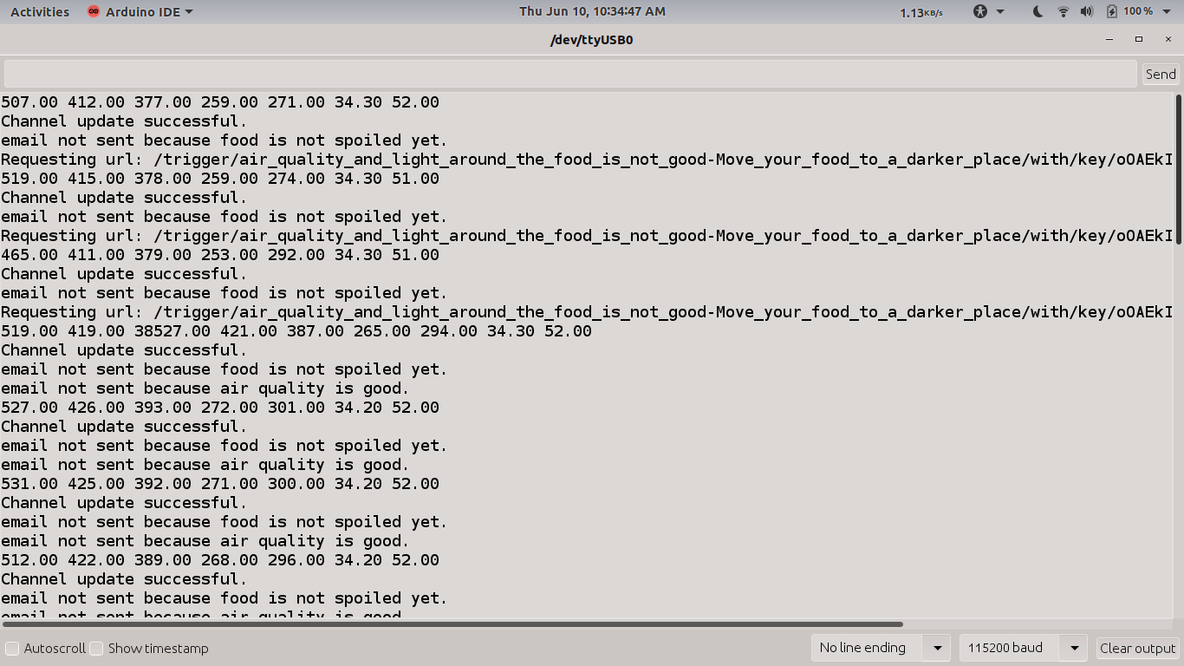

Nodemcu serial monitor output-1

The sensor data which is send from arduino is being displayed in statement 1[see above image].

The air quality and light around the food was not good. So, the device triggers the email. After trigging the first email, the food was placed [for experimentation]. Due to slow updates, the device immediately will not respond saying that the food is spoiled. From the image, the email corresponds to food spoilage is not triggered yet.

3

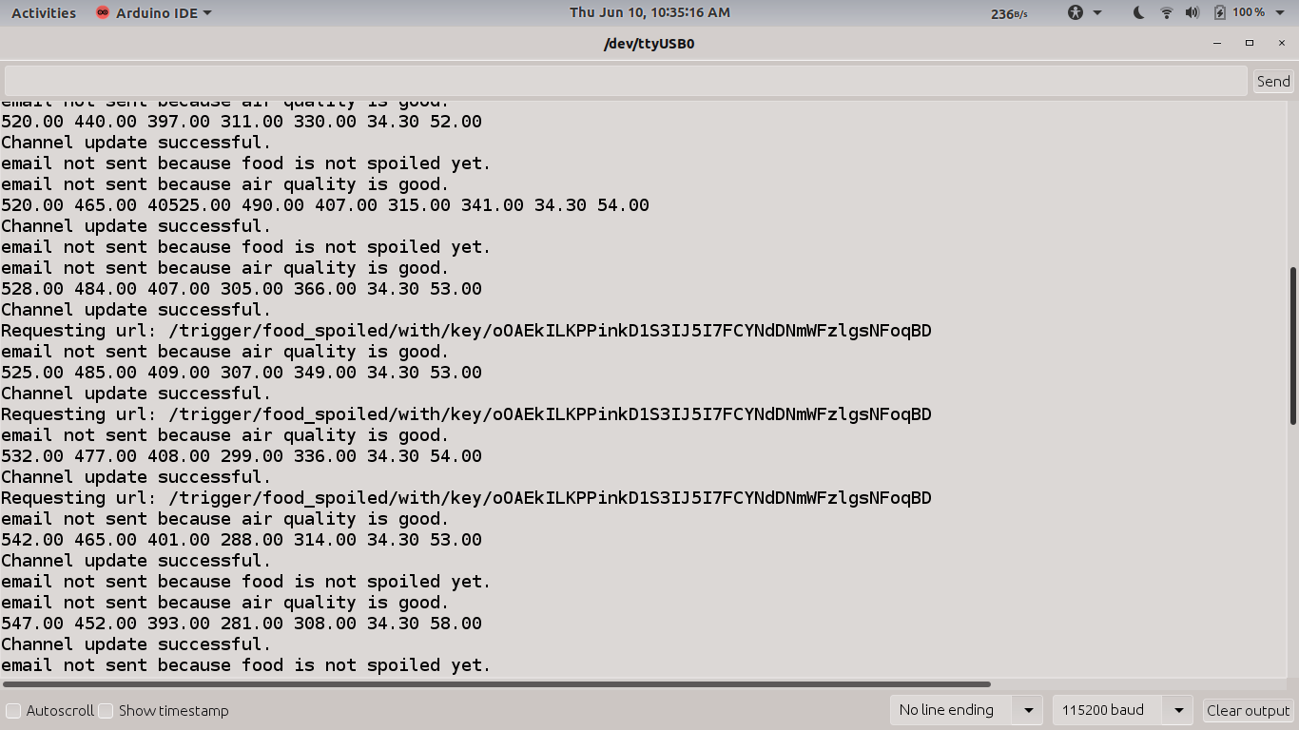

Nodemcu serial monitor output-2

After four to five updates, the email corresponding to food spoilage is triggered (statement 3). After the first email sent, the food was removed. Even though, the email was triggered because of slow updates.

Nodemcu serial monitor output-3

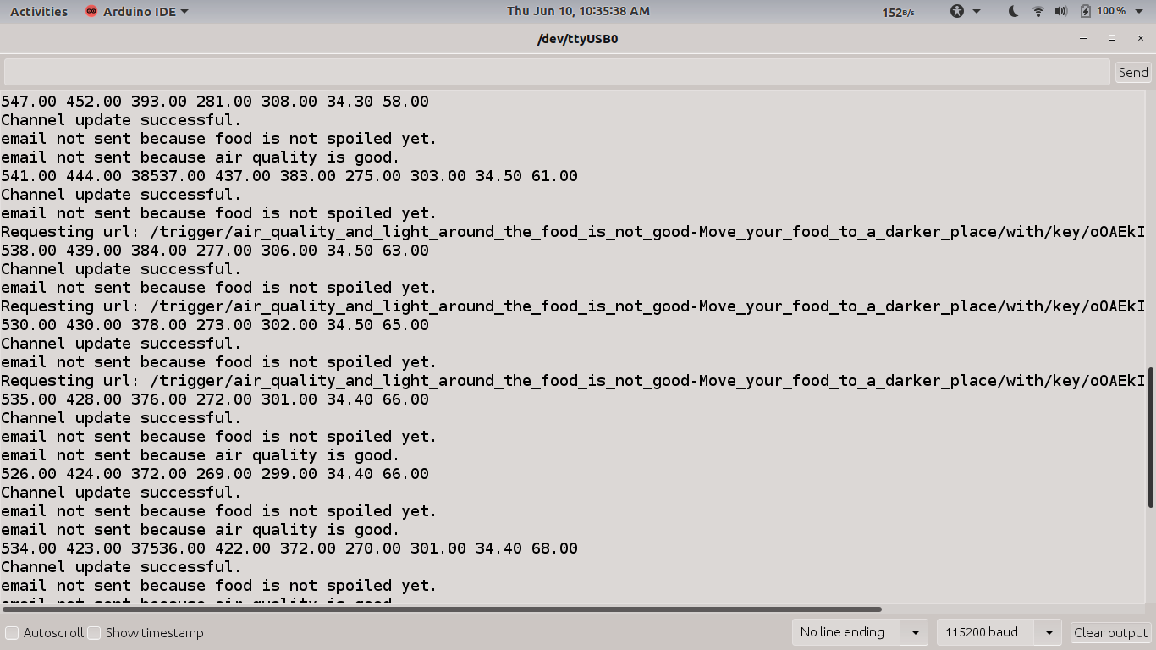

After a few minutes the device comes back to its initial state saying that the air quality around the food is not food.

**Note:** Thingspeak free version is being used. So, the updates the very slow and the performance will decrease slightly.

**PERFORMANCE EVALUATION:**

There is no standard performance evaluation metric to check the accuracy. The threshold values of each sensor is calculated by experimentation. The sensor is recorded in the cloud for every fourty seconds. So, fast and immediate results is not possible. Internet connection should be stable otherwise the data will be uploaded slowly which might decrease the performance of the system.

The performance should be evaluated by experimentation only.